**Instructions to Prepare Manuscripts for International Journal of Microwave and Optical Technology**

Editor-in-Chief*, Associate Editors and Editorial Board Members

ISRAMT, Department of Electrical Engineering University of Nevada, Reno, NV 89557, U.S.A. E-mail: [rawat@ee.unr.edu](mailto:rawat@ee.unr.edu)

***Abstract*-Use 10 points Times New Roman Bold letters for abstract. Set your line spacing to single line. The abstract should follow after two line spacing. It should have 200-1000 characters. Do not cite references in the abstract**

***Index Terms*- Maximum six key words or phrases in alphabetical order (10 font size), separated by commas like journal, maximum, microwave, optical, technology.**

1. INTRODUCTION

The manuscript should be submitted in English only and the presentation should be as succinct as possible. The total length of the manuscript including text, figures and references should not exceed 10 pages, Letter Size (8.5 in X 11 in or

21.59 cm X 27.94 cm) . The manuscript must have 2.5 cm spacing on top, bottom, left and right. The manuscript submission is a representation that it has not been archivally published before and is not currently under consideration for publication elsewhere. Manuscripts that are purely commercial in nature will not be considered for publication. The authors should indicate in a foot-note on the first page (10 point font size) if a preliminary report about the manuscript has appeared elsewhere or presented in the conferences etc. If so a copy of such publication should be attached at the time of submission for comparison purpose as the manuscript should have at least 60% additional work accomplished otherwise it will not be considered further. Please note that all the manuscripts are peer-reviewed by the editorial board members or other expert referees. The manuscripts accepted for publication are edited for conformance to IJMOT style and format.

Also the manuscripts may be accepted for publication as either full length paper or short- papers depending on the length or contents of the paper. All manuscript should use metric units unless to do so is not feasible or would result in a loss of clarity of the material.

The title of the paper should be centered in bold with the combination of capital and small letters of 18 font size followed by complete name(s) of author(s) with 11 font size after one line spacing and centered. The affiliation and complete mailing addresses should be written after one line spacing followed by telephone, fax and e-mail address of the corresponding author all in 10 font size. The corresponding author should be indicated with an asterisk*.

The section title “Introduction” should follow the index terms after two line spacing and the text should start after one line spacing from Introduction without any indentation. Make sure that abstract (included) onward the manuscript is in two column format with 10mm spacing between the columns. Use 11 point Times New Roman font or its equivalent for entire manuscript except tables and references.

Any new paragraph should start with double spacing from previous paragraph without indentation. Each section heading of the text should be in CAPITAL letters and should be numbered in Greek Letter viz. I, II, III, etc. Each section heading should start after one line spacing from the previous section and should be centered. The references should be cited in the text as [1], [2-5] etc. Any new section title should start after two line spacing from the last line of the previous section.

*A. Sub-section Heading*

The subsection heading should also use Capital and small letters in *Italic* and it should be spaced one line from the previous paragraph. The subsection heading should be numbered as *A, B*, etc. The text should start after one line spacing and should not have any indentation.

1. FILES REQUIRED

At this time we are accepting papers in PDF format only but in future the following formats will be acceptable: *For text*: Microsoft word, LaTex, PDF or Post Script and *For Figures*: PostScript, PDF or EPS. Your PDF should be created using high resolution settings especially the colored images.

1. EQUATIONS

All the complex equations should be created by using Word’s Equation Editor or using Math type which can be accessed via the menu structure “Insert/Object/Microsoft Equation”. Do not use font changes to enter symbols. Complex formulae, by definition, are those that require a line of their own and should be numbered:

2*x*3  3*x*2  *x*  5

the figure should be clear and readable. The caption should be in 10 font size and be preceded and followed by one line spacing. Only the first character in the caption should be in capital. If your figure has two parts, include the labels “(a)” and “(b)” as part of the artwork.

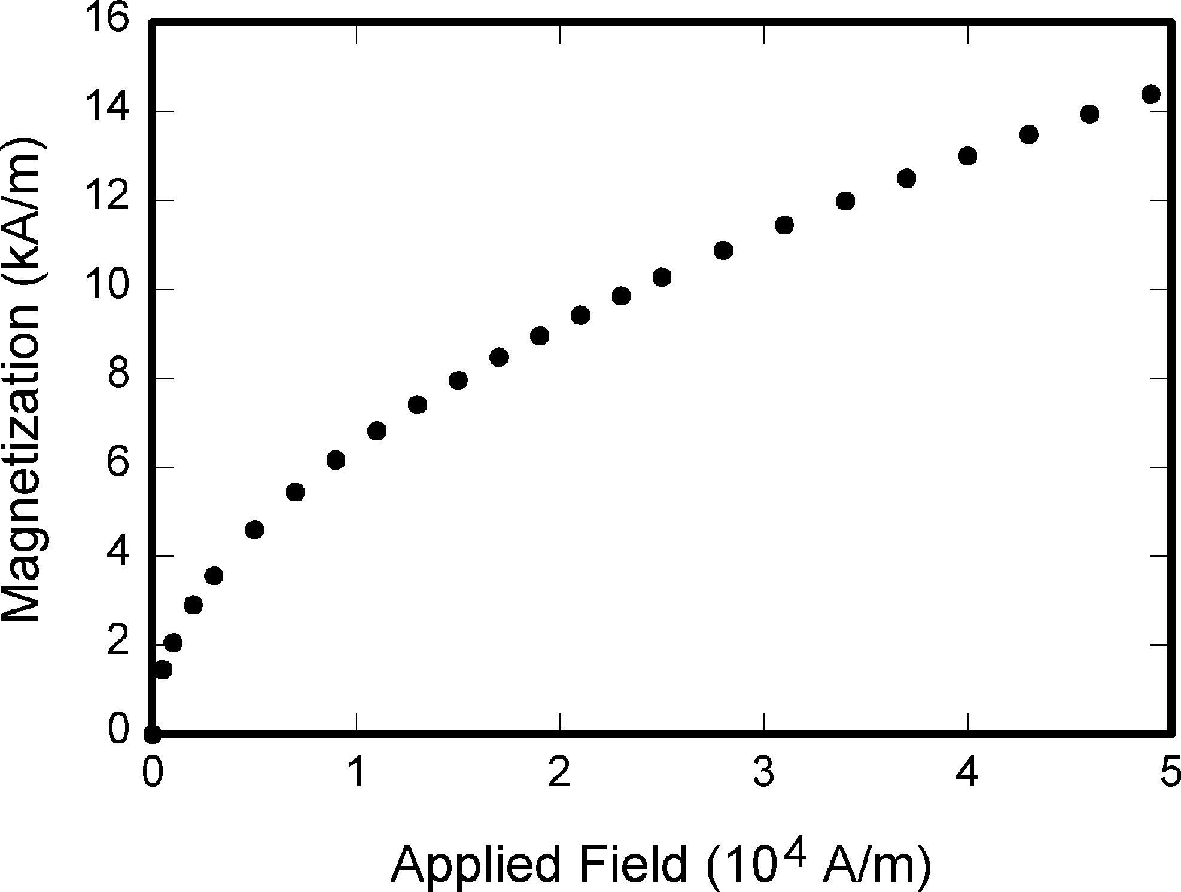

Fig.1. Variation of magnetization with applied field

* 1. TABLES

Tables should be typeset in Arial and should have a border of 0.25 pt. Their width should be either one column or two columns depending on the

size of the table. The table title should be on the top of the table, centered in the column, in 10

*F* (*x*) 

2*ax*2  5*bx*  *c*

(1)

font size, while inside the table you should use 8 font size. The first character of the title should be

Simple formula can be set by Word’s character formatting tools like: **bold**, *italic* or symbol: α, β, δ as well as superscript and subscript through Word’s Format/Font menu.

IV. FIGURES

Figure caption should be written as shown in Fig.1. Figures should be large enough to be easily viewed on a computer screen. All the figures should fit within one column unless it is very large figure and requires both the columns to avoid loss of clarity. The text inside and outside

in capital as shown in Table 1. The table title should be preceded and followed by one line spacing.

Table 1: Calculated and measured values of spurious resonance frequencies

|  |  |  |
| --- | --- | --- |
| Harmonics of pass- band center frequency, MHz | Center frequency of spurious pass-band, MHz | |
| Calculated | Measured |
| 1717.00 | 1521.91 | 1518.75 |
| 2575.50 | 2185.32 | 2183.67 |
| 3434.00 | 3043.82 | 3042.12 |

* 1. CONCLUSION

Conclusion is an important part of a paper and it should review the main points of the paper. Please be advised that the abstract should not be repeated here. It may also suggest importance of the work, applications and future extensions.

APPENDIX

Appendices, if any should be given before the acknowledgement.

ACKNOWLEDGMENT

All the acknowledgments should be given here including sponsoring and supporting agencies.

REFERENCES

Use 9 font size for all the references.

1. M. Makimoto and S. Yamashita, “Compact band- pass filters using stepped impedance resonators”, *IEEE Trans. Microwave Theory Tech.*, Vol. 40, pp. 16-19, Jan. 1979.
2. G.L. Matthaei, L. Young and E.M.T. Jones, *Microwave Filters, Impedance-Matching Networks and Coupling Structures*, 1st ed., Artech House, Massachusetts, 1980.
3. S. Singh, “Design of microwave wideband impedance matching networks”, M.S thesis, Dept. of Electrical Engineering, University of Nevada, Reno, USA, December 1995.
4. S.L. March, “Empirical formulas for the impedance and effective dielectric constant of covered microstrip for use in MIC CAD”, *Proc. European Microwave Conf.*, Microwave Exhibitors & Publishers Ltd., Kent, U.K., pp. 671- 676, Sept. 1981.
5. H. Ogawa, “Technologies and standardization of millimeter-wave wireless personal area network”, *Digest of 10th International Symposium on Microwave and Optical Technology”*, Fukuoka, Japan, pp. 12-14, August 22-25, 2005.